Date: | XXX |  | Site Number: |  | XXX
GPS Co. Latitude (WGS84) |  | XXXXXº |  | GPS Co. longitude (WGS84) |  | XXXXXX º

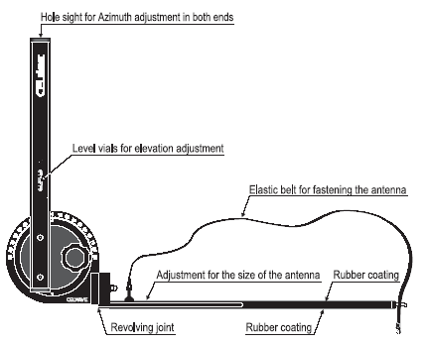

SECTOR |  | DEGREES | LEFT OR RIGHT | OF POINT
Sector 1
Sector 2
Sector 3

REFERENCE | AZIMUTH | LONGITUDE | LATITUDE

GPS with CELL ALIGNER antenna alignment instruction:
- Find a point of reference that is visible from the antenna location & at least 500mt away (Church, building, tree, pole).
- Go in that location with the GPS and mark the place. Get the co-ordinates
- Go back under the tower or on the roof and set the GPS to GoTo the reference point.
- The GPS will indicate the azimuth of the reference point/s from your location.
--- Ones you know the azimuth of 1 or more reference point/s, you will be able to determine the antenna orientation by:
- Ex. If sector 2 is 180º from North & the reference point (y) is 160º from North, You know that sector 2 is 20º right of (y) point.
- Ex. Sector 3 has to be installed at 280º. Find out where the previously installed Sec 2 is pointing with your alignment tool & then you know that Sec 3 is pointing 100º away (right) from where Sec 2 is pointing.

Date: | 19th JUNE 2004 |  | Site Number: |  | 01-234-Nosite
GPS Co. Latitude (WGS84) |  | 07.29595º |  | GPS Co. longitude (WGS84) |  | 002.28964 º

S1

(x)
S3

S2

(y)

SECTOR |  | DEGREES | LEFT OR RIGHT | OF POINT
Sector 1 | 60º | 15º | Left of point | X
Sector 2 | 180º | 20º | Right of point | y
Sector 3 | 280º | 120º | Right of point | y

REFERENCE | AZIMUTH | LONGITUDE | LATITUDE
Power Pole (x) | 75º | 07.29321º | 002.28432 º
Guyed Must (y) | 160º | 07.29132º | 002.28931 º
(z) |  | N | E

GPS with CELL ALIGNER antenna alignment instruction:
- Find a point of reference that is visible from the antenna location & at least 500mt away (Church, building, tree, pole).
- Go in that location with the GPS and mark the place. Get the co-ordinates
- Go back under the tower or on the roof and set the GPS to GoTo the reference point.
- The GPS will indicate the azimuth of the reference point/s from your location.
--- Ones you know the azimuth of 1 or more reference point/s, you will be able to determine the antenna orientation by:
- Ex. If sector 2 is 180º from North & the reference point (y) is 160º from North, You know that sector 2 is 20º right of (y) point.
- Ex. Sector 3 has to be installed at 280º. Find out where the previously installed Sec 2 is pointing with your alignment tool & then you know that Sec 3 is pointing 100º away (right) from where Sec 2 is pointing.

